**Lab 02 Submission Form**

**Name: Carlos Henrique Maciel Sobral Timoteo Student Number:** 040905599

**Task 1 Step 6:**

Straight forward

**Task 1 Step 8:**

IPv4 address: 192.168.1.127

Subnet Mask: 255.255.255.0

**Task 1 Step 9:**

Default Gateway: 192.168.1.1

**Task 1 Step 10:**

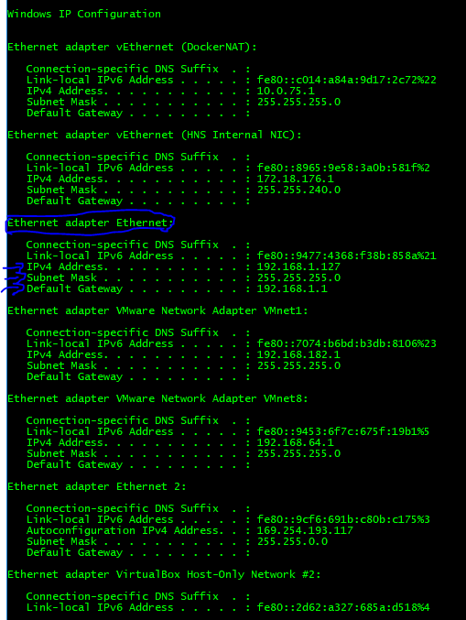

**Task 1 Step 12**

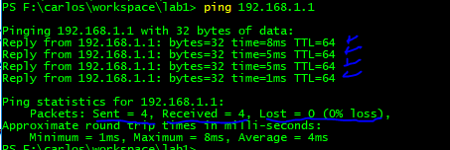

**Task 2 – Step 2**

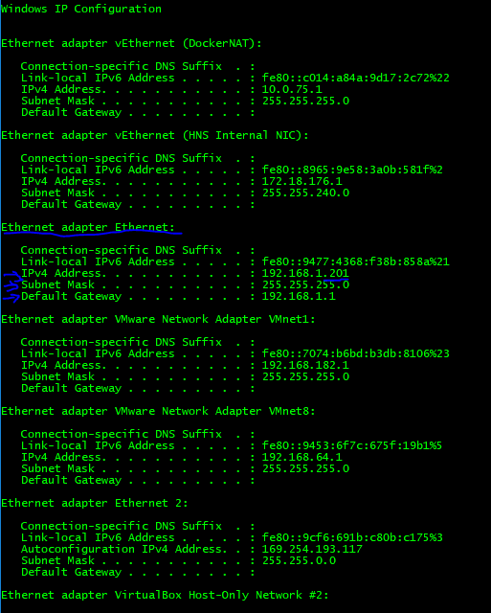

**Task 2 – Step 3**

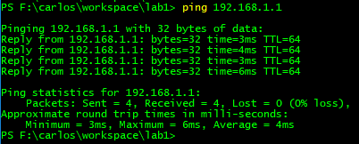

**Task 3 – Step 4**

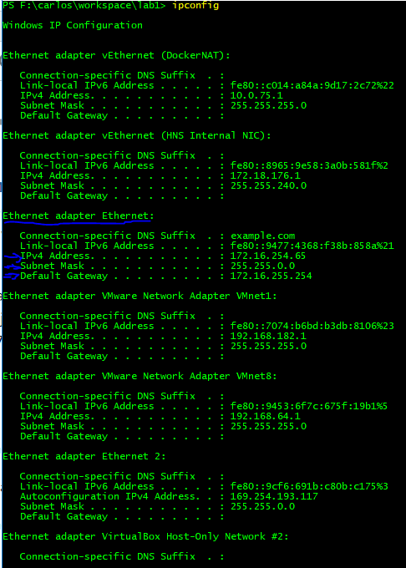

**Task 3 – Step 5**

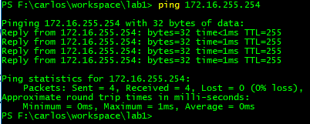

**Task 4 – Step 2B**

Too Many. ARP, CDP, DNS, SSDP, STP, DB-LSP-DISC, MDNS protocols messages.

**Task 4 – Step 2D**

Task performed in my Virtual Machine, that is why the source address is 172.16.254.76.

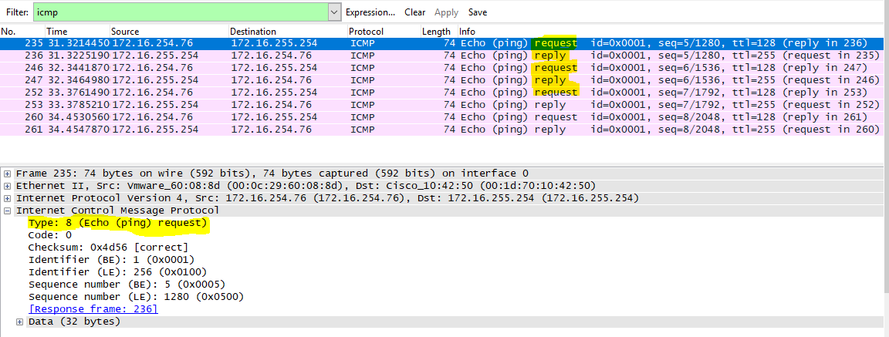

Type 8, Echo (ping) request.

**Task 4 –Step 2E**

Task performed in my Virtual Machine, that is why the source address is 172.16.254.76.

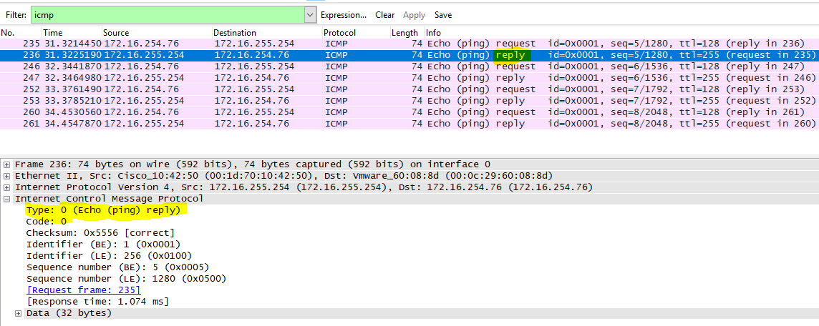

Type 0, Echo (ping) reply.

**Task 5 – Step 2**

10.50.11.45. Yes, I've never connected in Algonquin college wired network before. So, it is a new IP address for my ethernet network adapter.

**Task 5 – Step 3**

ipconfig /release

ipconfig /renew

**Task 5 – Step 4**

Pinging the gateway.

ping 10.50.11.1

No timeouts and 0% loss statistics.

**Task 5 – Step 7**

1. 10.70.193.255
2. ping 10.70.192.1

No timeouts and 0% loss statistics.

Pinging 10.70.192.1 with 32 bytes of data:

Reply from 10.70.192.1: bytes=32 time=10ms TTL=255

Reply from 10.70.192.1: bytes=32 time=7ms TTL=255

Reply from 10.70.192.1: bytes=32 time=155ms TTL=255

Reply from 10.70.192.1: bytes=32 time=8ms TTL=255

Ping statistics for 10.70.192.1:

Packets: Sent = 4, Received = 4, Lost = 0 (0% loss),

Approximate round trip times in milli-seconds:

Minimum = 7ms, Maximum = 155ms, Average = 45ms